Solution: Introduction to Guidewire Configuration

In this lab, you will start Guidewire Studio, debug TrainingApp from Studio, and then log in to TrainingApp. In TrainingApp, you will search for contacts and create new contacts. You will end this lab by exiting Guidewire Studio.

Requirements

This lab requires that you use TrainingApp 8.0, Guidewire Studio 8.0, and Chrome as your web browser. To view, edit, and delete various contacts, log in to TrainingApp as Alice Applegate. The default URL for TrainingApp is <http://localhost:8880/ab/ContactManager.do>. The login/password for Alice Applegate is aapplegate/gw.

1. Working with Guidewire Studio

In this exercise, you will open Guidewire Studio. You will then run and stop the TrainingApp server from Guidewire Studio.

Tasks

1. Open Guidewire Studio
2. Open a Command window from the TrainingApp bin folder.
3. In the Command window, start Guidewire Studio for TrainingApp.
4. Alternatively, use the Start TrainingApp Studio shortcut.
5. Debug the TrainingApp project
6. Use the main menu, toolbar, or keystroke to debug TrainingApp.
7. Verify that you are running TrainingApp
8. Verify that the Debug console is open.
9. Verify that the Console tab shows ***** ContactManager ready *****.

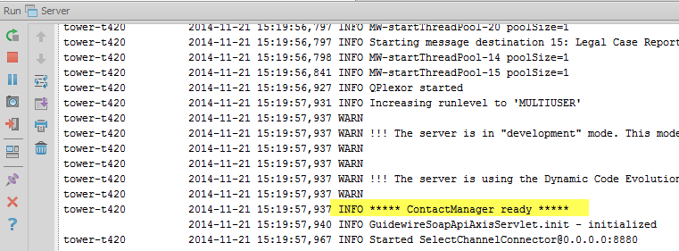

Write it down

What are the two ways that you can run the TrainingApp application from Guidewire Studio?

|  |
| --- |
| From the Run menu, select Run 'Server' or select Debug 'Server'. |

1. Explore TrainingApp

In this exercise, you will log in to TrainingApp as Alice Applegate. As Alice Applegate, you will search for contacts and create new contacts. Then, you will log out of TrainingApp. Finally, you will stop TrainingApp from the Guidewire Studio.

Tasks

1. Log in to TrainingApp
2. Log in as Alice Applegate.
3. Search for contacts with the last name Smith
4. Review the search results.

Write it down

How many contacts have the last name Smith?

|  |
| --- |
| 2 |

Describe the contact types with the last name Smith.

|  |
| --- |
| Robert Smith is a Person whereas Quaiche Smith is a Policy Person. |

1. Create a contact of the type Law Firm
2. Specify the following details:

|  |  |
| --- | --- |
| Field Name | Value |
| Name | Celebrity Law Office |
| Tax ID (EIN) | 11-1234567 |
| City | Hollywood |
| State | California |

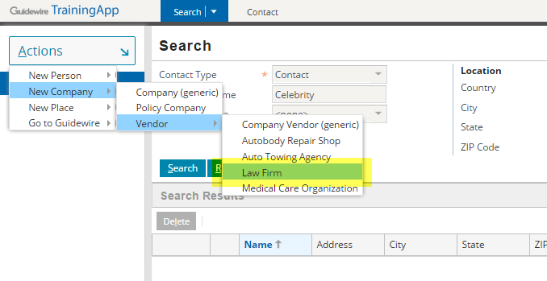

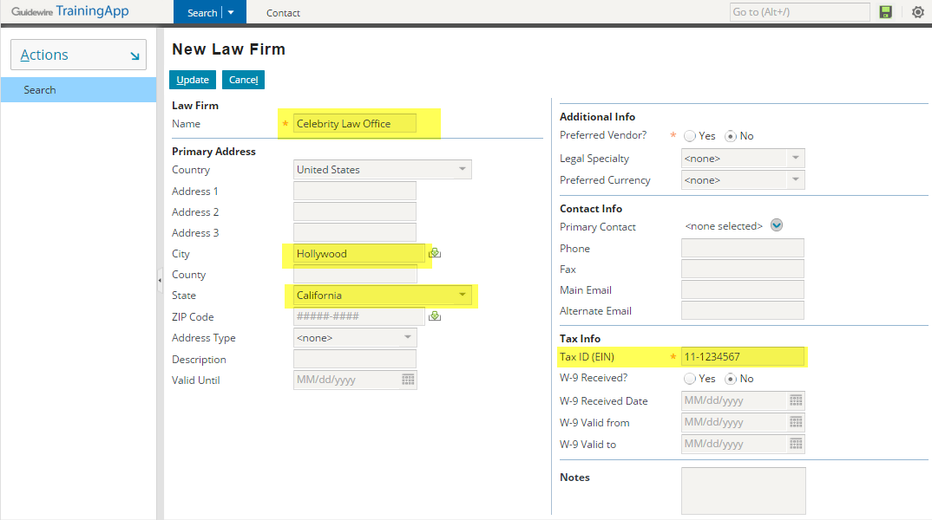

1. Create a contact of the type Autobody Repair shop
2. Specify the following details:

|  |  |
| --- | --- |
| Field Name | Value |
| Name | Celebrity Collision Repair |
| Tax ID (EIN) | 22-1234567 |
| City | Los Angeles |
| State | California |

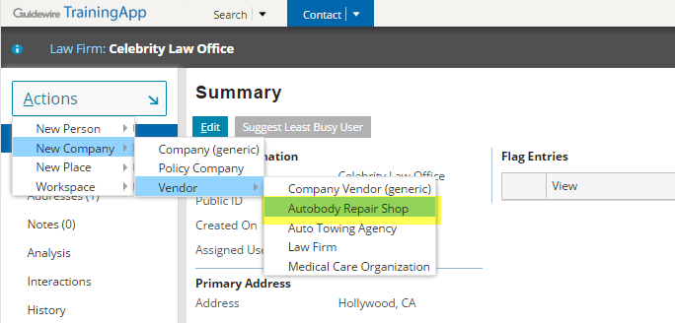

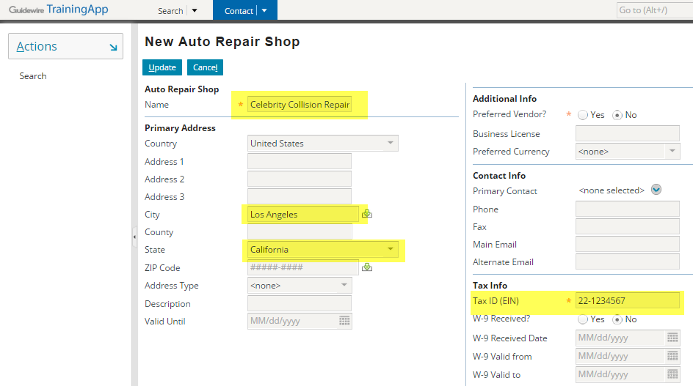

1. Search for contacts with the name Celebrity
2. Review the search results.
3. View the details for each contact in the results.

Write it down

On the Details screen for the Law Firm, in the Additional Info section, review the available fields. Next, review the available fields in the Additional Info section for the Autobody Repair Shop. Which fields differ between the Law Firm and the Autobody Repair Shop?

|  |
| --- |
| The Law Firm has a Specialty field whereas the Autobody Repair Shop has a License field. |

1. Log out of TrainingApp
2. In the Settings menu, select Log Out Alice Applegate.
3. Stop TrainingApp from Guidewire Studio
4. Stop the Debug 'Server' process.

Write it down

After stopping the server from Guidewire Studio, are you able to navigate in the TrainingApp web application? What is the browser error?

|  |
| --- |
| It is not possible to continue navigating the TrainingApp web application. The browser shows an error that say the webpage is not available. |

|  |  |
| --- | --- |
|  | Stop and ask your instructor to review your completed lab. |